EXP 5: Create a simple cloud software application for Library book reservation system for SIMATS library using any Cloud Service Provider to demonstrate SaaS.
DATE:02-03-26
AIM:
PROCEDURE:
STEP1:GO TO ZOHOCREATOR.COM AND LOGIN TO YOUR ACCOUNT
STEP2:CLICK CREATE NEW APPLICATION AND CREATE FROM SCRATCH
STEP3: ENTER APPLICATION NAME AND CREATE APPLICATION
STEP4:CLICK ON CREATE NEW FORM AND NAME THE FORM
STEP5:ENTER THE DETAILS
STEP6:THE SOFTWARE HAS BEEN CREATED.

STEP1:GO TO ZOHOCREATOR.COM AND LOGIN TO YOUR ACCOUNT

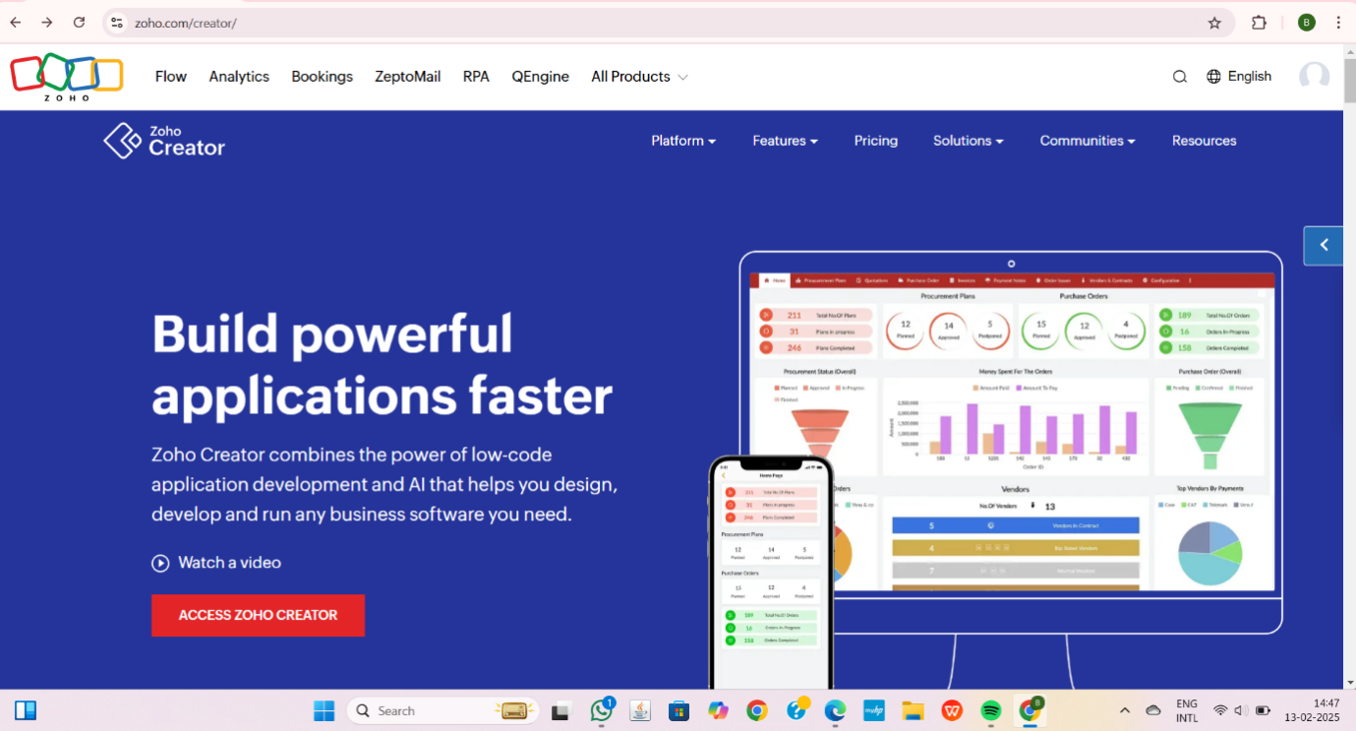

STEP2:CLICK CREATE NEW APPLICATION AND CREATE FROM SCRATCH
STEP3: ENTER APPLICATION NAME AND CREATE APPLICATION

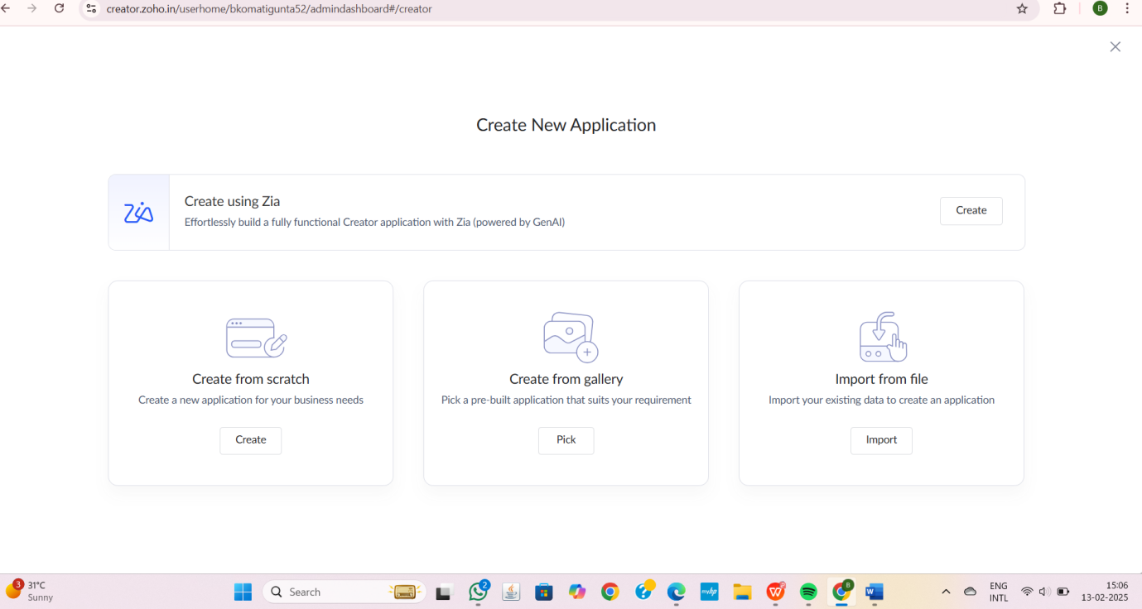

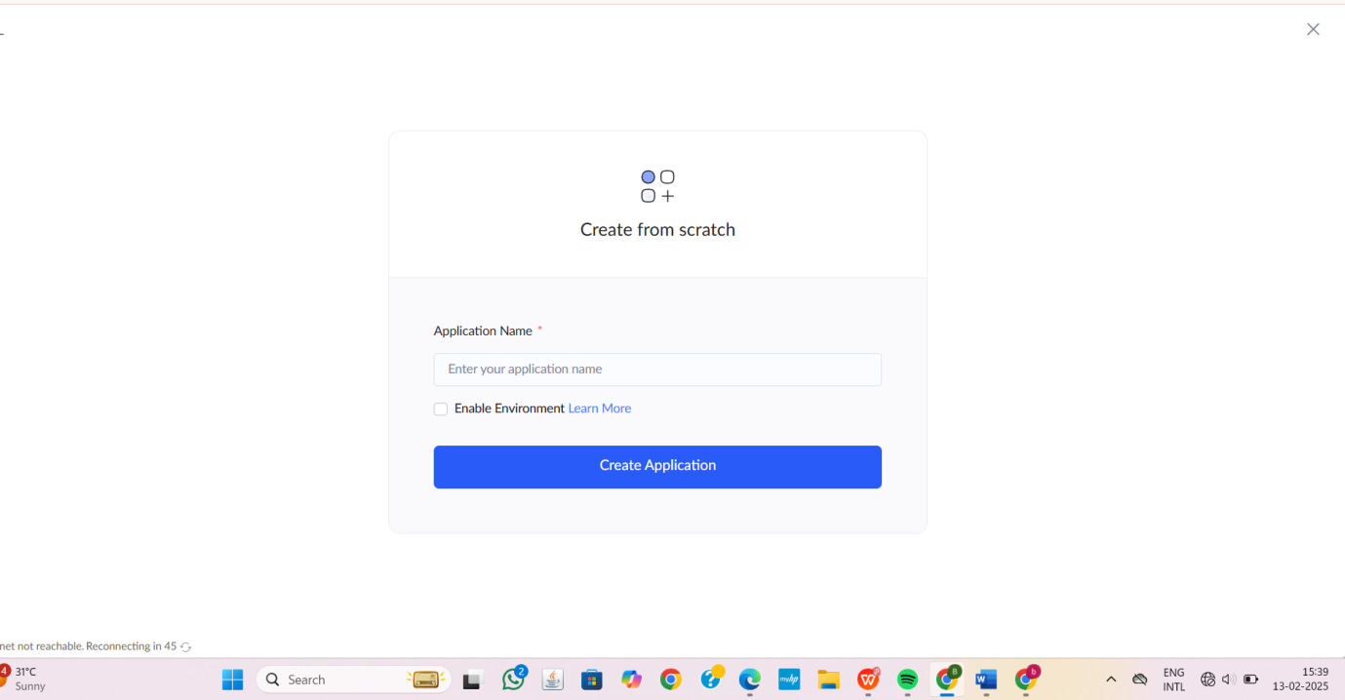

STEP4:CLICK ON CREATE NEW FORM AND NAME THE FORM

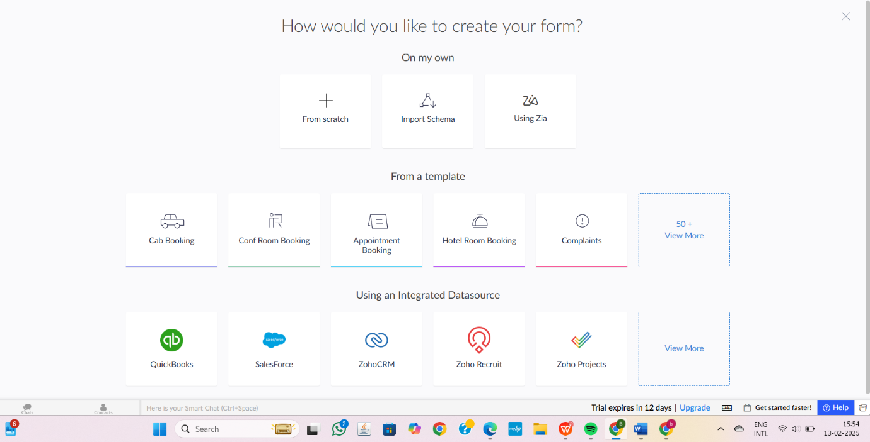

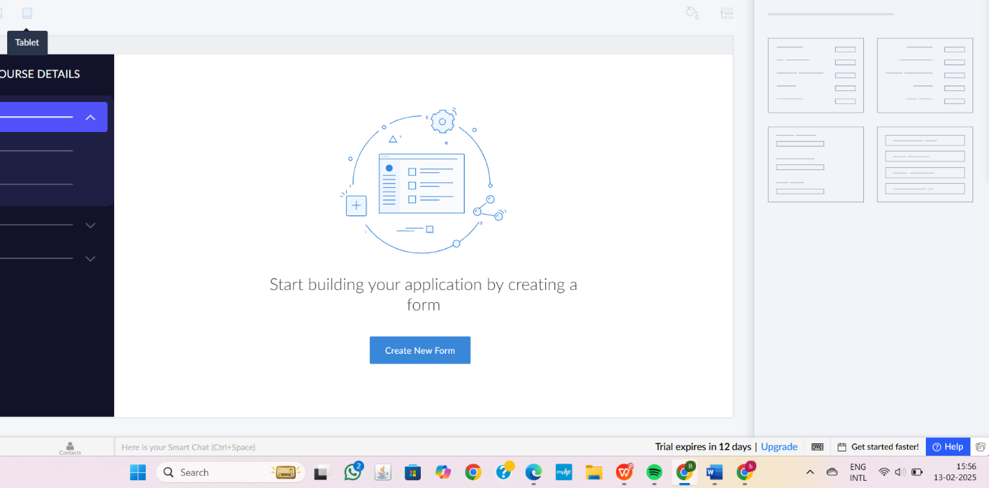

1.STUDENT DETAILS
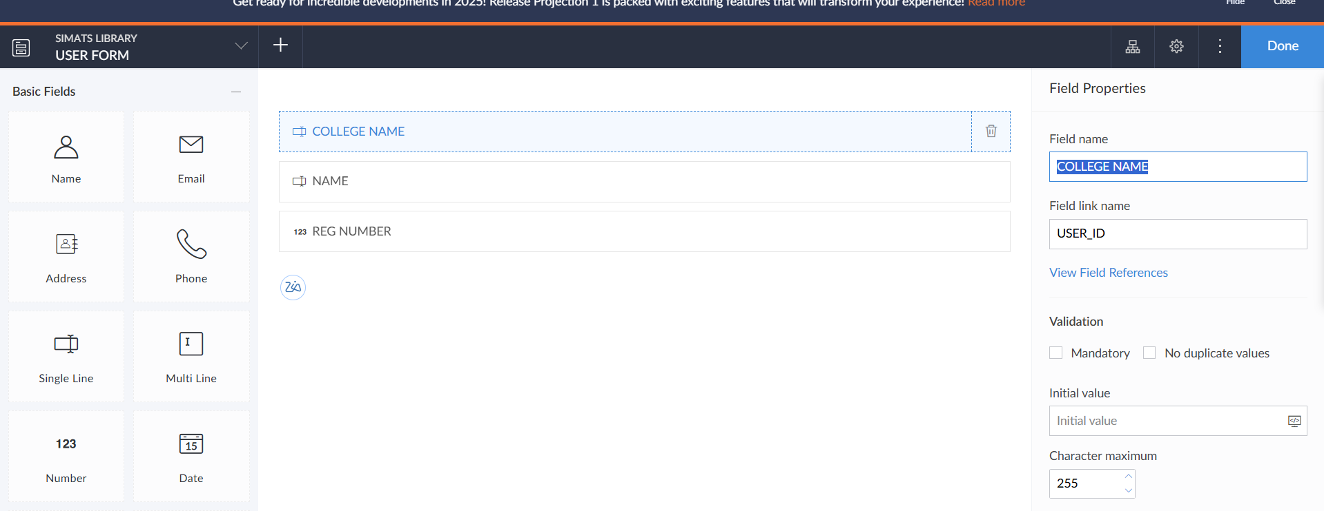

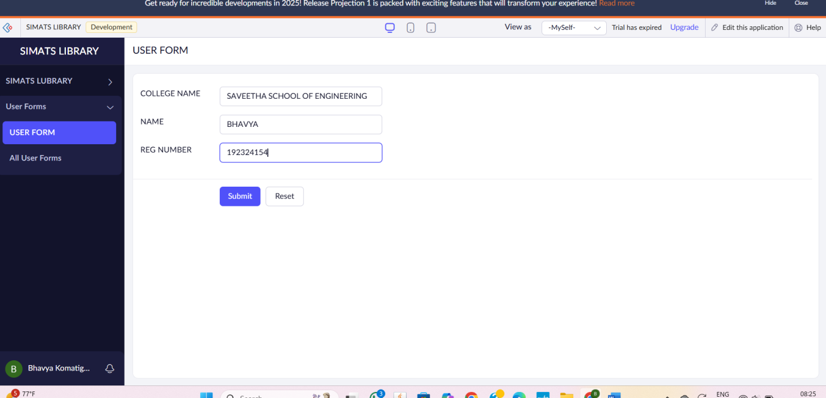

2.BOOK DETAILS
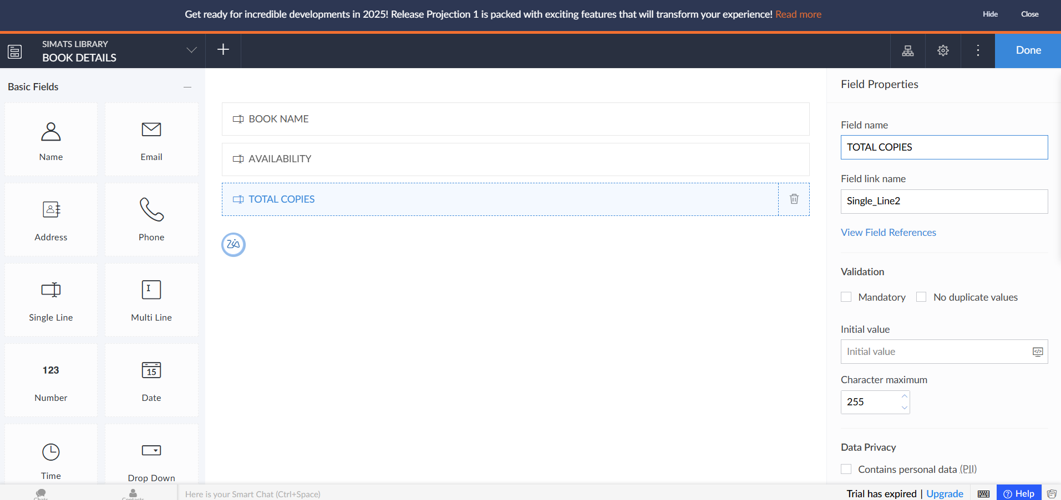

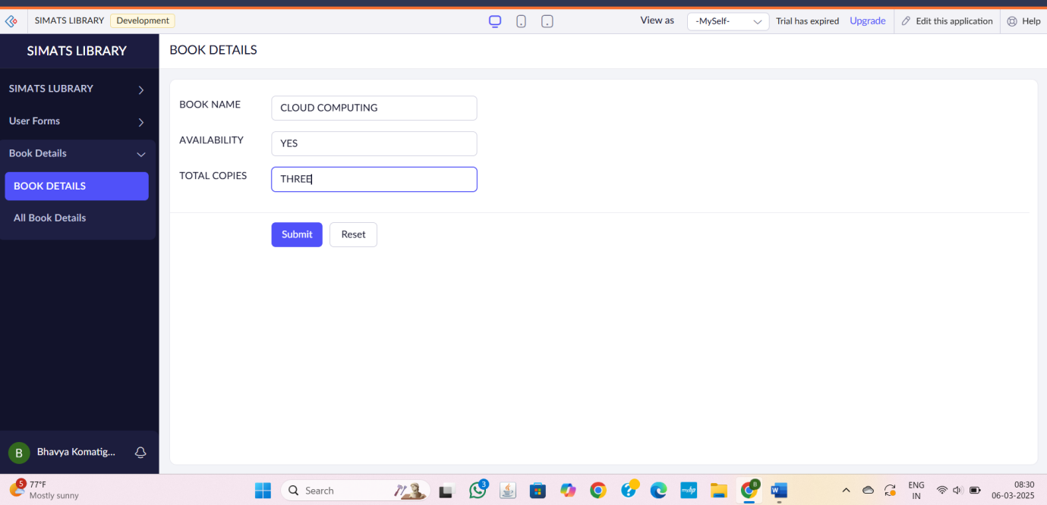

3.RESERVATION OF BOOK DETAILS
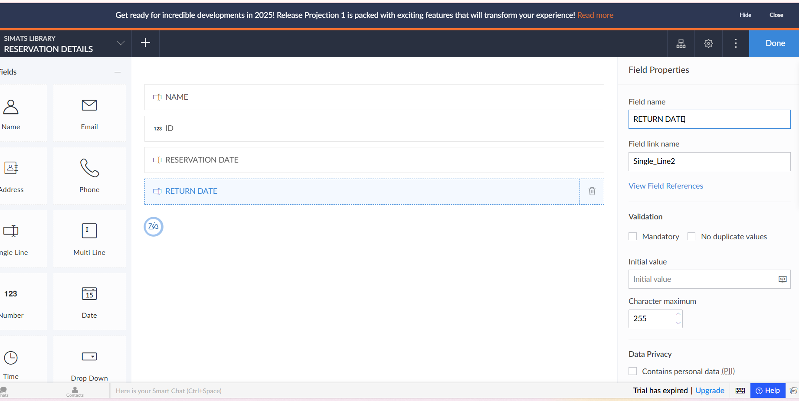

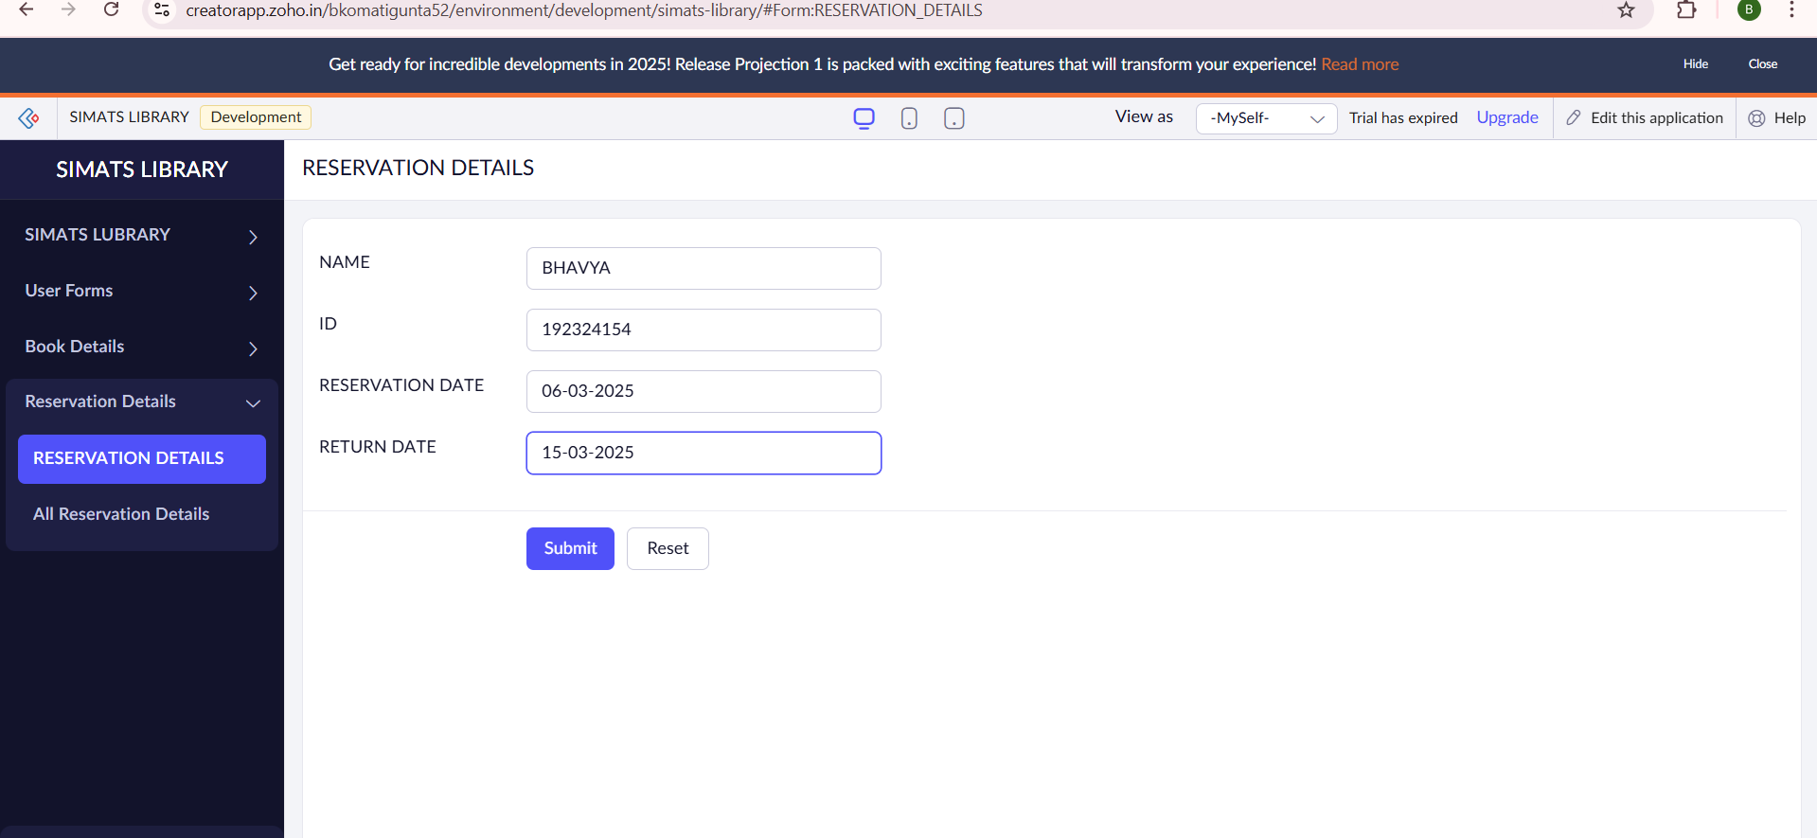

STEP6:THE SOFTWARE HAS BEEN CREATED.
